** MINISTRY OF EDUCATION AND TRAINING**

**FPT UNIVERSITY**

Capstone Project Document

The Roll System using Mobile Device

|  |  |
| --- | --- |
| **Group 1** | |
| **Group member** | Pham Huy Hoang – Team Leader – 60740  Nguyen Thanh Binh – Team Member - 60321  Nguyen Quoc Huy – Team Member - 60551  Do Minh Dat – Team Member - 60545 |
| **Supervisor** | Mr. Kieu Trong Khanh |
| **Ext. Supervisor** | N/A |
| **Capstone Project code** | RSM |

-Ho Chi Minh City, 09/2013-

*This page is intentionally left blank*

***ACKNOWLEDGEMENTS***

We wish to thank various people for their contribution to this project: Our teachers for their advices and participant in the final review, our friend for the valuable technical support.

Special thanks should be given to Mr.Kiều Trọng Khánh, our research supervisor for his professional guidance and the useful, constructive recommendations throughout the course of this project.

# Table of Contents

**Table of Contents 4**

**List of Tables 6**

**List of Figures 7**

A. Introduction 8

1. Project Information 8

2. Introduction 8

3. Current Roll Call System 8

4. Problem Definition 8

5. Proposed Solution 9

5.1 Feature functions 9

5.2 Advantage and disadvantage 9

6. Functional Requirement 10

6.1 Create Account 10

6.2 Instructor Management 10

6.3 Class Management 10

6.4 Student Management 10

6.5 Course Management 10

6.6 Roll Call Management 10

6.7 Attendance Checking 10

6.8 Stranger Alert 10

6.9 Attendance Report 11

7. Role and Responsibility 11

B. Software Project Management Plan 12

1. Problem Definition 12

1.1 Name of this Capstone Project 12

1.2 Problem Abstract 12

1.3 Project Overview 12

2. Project organization 14

2.1 Software Process Model 14

2.2 Roles and responsibilities 15

2.3 Tools and Techniques 16

3. Project Management Plan 17

3.1 Iteration 17

3.2 Iteration Detail 19

3.3 All Meeting Minutes 23

4. Coding Convention 23

# List of Tables

Table 1: Roles and Responsibility 11

Table 2: Hardware Requirement for Server 14

Table 3: Hardware Requirement for Mobile App 14

Table 4: Roles and Responsibility Details 16

Table 5: Iteration 18

Table 6: Phase 1: Preliminary Investigation or Analysis 19

Table 7: Phase 2: Face Detect & Recognize 20

Table 8: Phase 3: Student Management 20

Table 9: Phase 4: Roll Call Management 21

Table 10: Phase 5: Web Service Implement 22

Table 11: Phase 6: Attendance Checking 22

Table 12: Phase 7: Attendance Report 23

# List of Figures

Figure 1: Agile Development Model 15

# Introduction

## Project Information

* Project name: **The roll system using mobile device**
* Project Code: **RSM**
* Product Type: **Website, Phone Application**
* Start Date: **September 9th, 2013**
* End Date:

## Introduction

Roll system was known with HPLite32, SimplePass of HP fingerpint system; roll system with ID card using by almost corporation or company around the world; the system face identify by Uniqul – Finland publish on 7/15/2013 or LogonSmart by Asus. Today, the trend machines replace humans in the hard work or the work does not require high intelligence became popular. So roll system face recognition becomes ever more necessary. The number of students in a university as well as the number of employees in large corporations in Vietnam is increasing dramatically, which means that the system should have professional roll with accuracy high.

## Current Roll Call System

Below are some current roll call systems:

* By manual: This system is widely used in school, university. The instructor will call the name of each student, check the absent, then submit the result to log system.
* Using ID card: This system is usually used in corporations. Each employee has a card. The card will be read by a card reader to check the attendance of the employee.
* Using fingerprint: This system is currently used in FPT University. 15 minutes before and after a studying session, the student must show his fingerprint to a machine to take attendance.
* Using camera + face recognition: This system is just in experimental stage. Each classroom has a camera. At the beginning of the studying session, the instructor uses the computer, connect to the camera and take picture of classroom. The system will recognize the student in the picture, write to roll call log system.

## Problem Definition

Below are the advantage and disadvantage of current roll call systems:

* By manual

+ Advantage: Simple to implement, cheap.

+ Disadvantage: The roll call take 3-5 minutes, take effort of instructor, wrong roll call.

* Using ID card

+ Advantage: High accuracy, not take much effort to check attendance.

+ Disadvantage: High cost (ID Card, Card Reader). Risk of ID card missing.

* Using fingerprint

+ Advantage: Quickly. No effort must be made from instructor.

+ Disadvantage: Cost of fingerprint reading machine. Risk of machine error. The student checks the attendance but not go to class.

* Using camera + face recognition

+ Advantage: Quickly. The entire class picture can be stored as log.

+ Disadvantage: High cost (Camera cost). Face recognition not too accuracy.

## Proposed Solution

The system is intended for used in only school or university, where the pupils/students sit in a classroom (A small classroom, from 20-30 students). The system must to manage the course, teacher, check attendance…. In detail, the system will enable following function:

### **Feature functions**

* The admin can manage information about course, class, instructor, students.
* The system will provide a method for admin to upload the student’s images, select the students in the images to make training data.
* The system will make a roll call list (Contains: Course, Class, Time, Instructor, Student List) for each class, based on the input information.
* The system will provide a method to assign instructor and student to course. The system must check the availability of the instructor before assigning.
* The system must support a method to change instructor of a course (When instructor is sick or busy).
* The system can output report about the absent rate of a course, or a student.
* The instructor/examiner (fix other place) can view info about: What course they are teaching. Roll Call and student lists of these classes.
* The instructor will use the mobile application. At the beginning of a studying session, a picture of entire class will be taken for checking attendance.
* Base on the student list, the system will recognize the students from the picture. The mobile app will notify attendance result to instructor.
* The instructor can, re-check attendance manually.
* The system will alert the instructor when it detects stranger in classroom.
* Based on the respond from instructor, the system will gather more data to become more accuracy.
* The student can view info about what course they’re studying.
* The student can view their own attendance of the course they participated in.

### Advantage and disadvantage

The advantage and disadvantage of the proposed solution:

* Advantage: Small cost or no cost (If the instructor has phone). Face Recognition accuracy is about 70~80%, will reach 100% with confirm from instructor. The attendance check is quickly (< 30 seconds). The taken picture can be stored as log.
* Disadvantage: Complex to implement. The accuracy can vary depend on: Noise, brightness, number of people, image solution… Need student’s picture to be used for recognition training.

## Functional Requirement

Function requirement of the system are listed as below:

### Create Account

* The account of instructors and students will be auto-created by the system, basing on the input from admin.
* The instructors and students can change their profile and password.

### Instructor Management

* The staff can add/edit/active/inactive instructor.

### Class Management

* The staff can add/edit/active/inactive class.

### Student Management

* The admin can add/edit/active/inactive student.
* Each student must has a training set, contains 8-20 images for face recognizing. The staff can upload images, select the faces of the students to add. The staff can also remove images from training set.

### Course Management

* The staff can add/edit/active/inactive course.

### Roll Call Management

* The staff can add/edit/active/inactive roll call.
* The staff must input info of a roll call: The course, the instructor who teaches the course, the student list, the time of the course (Begin, End Date).
* The instructor can see what roll call they belong to.
* The instructor can change their roll call to another instructor, in case of sickness or busy.

### Attendance Checking

* At the beginning of each studying session, the instructor takes a picture of entire class for attendance checking.
* The instructor can re-check attendance manually.
* The mobile app will notify the result to the instructor.
* In case of wrong recognition, the student face will be added to training set for higher accuracy.
* The instructor can view the attendance log of the course they are teaching.
* The student can view the attendance log of the course they are studying.

### Stranger Alert

* If stranger is detected in the classroom, the system will alert to teacher. A log file will also be written.
* In case of wrong recognition, the student face will be added to training set for higher accuracy.

### Attendance Report

* The system will make attendance report, which shows the rate of absence in a course, or the rate of absence of a student.
* The report is only available to staff and instructor

## Role and Responsibility

|  |  |  |  |  |
| --- | --- | --- | --- | --- |
| **No** | **Full Name** | **Role** | **Position** | **Contact** |
| 1 | Kiều Trọng Khánh | Project Manager | Instructor | khanhkt@fpt.edu.vn |
| 2 | Phạm Huy Hoàng | Developer | Team Leader | hoangphse60740@fpt.edu.vn |
| 3 | Nguyễn Thanh Bình | Developer | Team Member | [binhnt60321@fpt.edu.vn](mailto:binhnt60321@fpt.edu.vn) |
| 4 | Nguyễn Quốc Huy | Developer | Team Member | [huynq60551@fpt.edu.vn](mailto:huynq60551@fpt.edu.vn) |
| 5 | Đỗ Minh Đạt | Developer | Team Member | datdm60545@fpt.edu.vn |

Table 1: Roles and Responsibility

# Software Project Management Plan

## Problem Definition

### Name of this Capstone Project

The roll system using mobile device (RSM)

### Problem Abstract

Roll system was known with HPLite32, SimplePass of HP fingerpint system; roll system with ID card using by almost corporation or company around the world; the system face identify by Uniqul – Finland publish on 7/15/2013 or LogonSmart by Asus. Today, the trend machines replace humans in the hard work or the work does not require high intelligence became popular. So roll system face recognition becomes ever more necessary. The number of students in a university as well as the number of employees in large corporations in Vietnam is increasing dramatically, which means that the system should have professional roll with accuracy high.

### Project Overview

#### The Current System

Below are some current roll call systems:

* By manual: This system is widely used in school, university. The instructor will call the name of each student, check the absent, then submit the result to log system.

+ Advantage: Simple to implement, cheap.

+ Disadvantage: The roll call take 3-5 minutes, take effort of instructor, wrong roll call.

* Using ID card: This system is usually used in corporations. Each employee has a card. The card will be read by a card reader to check the attendance of the employee.

+ Advantage: High accuracy, not take much effort to check attendance.

+ Disadvantage: High cost (ID Card, Card Reader). Risk of ID card lending, missing.

* Using fingerprint: This system is currently used in FPT University. 15 minutes before and after a studying session, the student must show his fingerprint to a machine to take attendance.

+ Advantage: Quickly. No effort must be made from instructor.

Disadvantage: Cost of fingerprint reading machine. Risk of machine error. The student checks the attendance but not go to class.

* Using camera + face recognition: This system is just in experimental stage. Each classroom has a camera. At the beginning of the studying session, the instructor uses the computer, connect to the camera and take picture of classroom. The system will recognize the student in the picture; write to roll call log system.

+ Advantage: Quickly. The entire class picture can be stored as log.

+ Disadvantage: High cost (Camera cost). Face recognition not to accuracy.

#### The Proposed System

The system is intended for used in only school or university, where the pupils/students sit in a classroom. The system must to manage the course, teacher, check attendance…. In detail, the system will enable following function:

##### Web

* The admin can manage information about course, class, instructor, students.
* The system will provide a method for staff to upload the student’s images, select the students in the images to make training data.
* The system will make a roll call list (Contains: Course, Class, Time, Instructor, Student List) for each class, based on the input information.
* The system will provide a method to assign instructor and student to course. The system must check the availability of the instructor before assigning.
* The system must support a method to change instructor of a course (When instructor is sick or busy).
* The system can output report about the absent rate of a course, or a student.
* Based on the respond from instructor, the system will gather more data to become more accuracy.
* The student can view info about what course they’re studying.
* The student can view their own attendance of the course they participated in.

##### Mobile

* The instructor can view info about: What course they are teaching. Roll Call and student lists of these classes.
* The instructor will use the mobile application to take a picture.
* The mobile shows the list of student present in class, notify the instructor if absent rate is high.
* The instructor can re-check attendance manually.
* The system will alert stranger.

#### Boundaries of the System

* The system is intended for using university, with small classroom, or for the examine room (The testing site will be FPT University).
* The maximum number of a classroom is 30 people. The classroom size is about: 6m x 8m
* The system is not intended for managing these aspect:

+ Managing the teaching calendar of instructor.

+ Managing instructor qualification, salary info.

+ Managing the testing, mark of student of each class.

* The language of the system is English.
* The complete product includes:

+ The website, for admin and students. Instructor can also use the website to change profile, view roll call info.

+ Mobile Application for instructor to check attendance.

+ All the process involved document.

#### Development Environment

##### Hardware requirements

**For server**

|  |  |  |
| --- | --- | --- |
| Windows | Minimum Requirements | Recommended |
| Internet Connection | Cable, Wifi (4 Mbps) | Cable, Wifi (8 Mbps) |
| Operating System | XP, Vista, 7, 8 | XP, Vista, 7, 8 |
| Computer Processor | Intel® Core 2 Duo | Intel® Core(TM) i5 CPU , M 460 @ 2.53GHz |
| Computer Memory | 1GB RAM | 3GB or more |

Table 2: Hardware Requirement for Server

**For Mobile Application**

|  |  |  |
| --- | --- | --- |
| Mobile | Minimum Requirements | Recommended |
| Internet Connection | Wifi (2Mbps) | Wifi (4Mbps) |
| Operating System | Android 4.0 or later version | Android 4.4 |
| Hardware | Touchscreen, Camera 2.0 MP or above | Touchscreen, Camera 4.0 MP or above |
| Memory | 512 MB or more | 1 GB or more |

Table 3: Hardware Requirement for Mobile App

##### Software requirements

* Microsoft Windows 7 Service Pack 1: operating system and platform for development.
* SQL Server 2008 Express: used to create and manage the database for system.
* StarUML: used to create models and diagrams
* Skype: used for communication and meeting
* Visual Studio 2010: used to implement website and web service.
* Eclipse Juno 4.4, Android SDK 22.0.5, ADT 22.0.5 & JDK 7u25: used to implement mobile application.
* Google Code & TortoiseSVN: used for source control.

## Project organization

### Software Process Model

Project is developed under agile model.

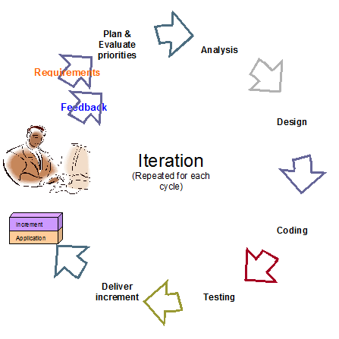

Figure 1: Agile Development Model

For more information: <http://www.indicthreads.com/1439/quick-introduction-to-agile-software-development/>

(Owner: IndicThreads.com. Online Software Developer Magazine and Conferences)

### Roles and responsibilities

|  |  |  |  |
| --- | --- | --- | --- |
| **No** | **Full name** | **Role in Group** | **Responsibilities** |
| **1** | Kiều Trọng Khánh | Project manager | * Specify user requirement * Control the development process * Give out technique and business analysis support |
| **2** | Phạm Huy Hoàng | Team Leader, BA, DEV, Tester | * Managing process * Designing database * Clarifying requirements * Prepare documents * GUI Design * Create test plan * Coding * Testing |
| **3** | Nguyễn Thanh Bình | Team Member, BA, DEV, Tester | * Designing database * Clarifying requirements * Prepare documents * GUI Design * Create test plan * Coding * Testing |
| **4** | Nguyễn Quốc Huy | Team Member, BA, DEV, Tester | * Designing database * Clarifying requirements * Prepare documents * GUI Design * Create test plan * Coding * Testing |
| **5** | Đỗ Minh Đạt | Team Member, BA, DEV, Tester | * Designing database * Clarifying requirements * Prepare documents * GUI Design * Create test plan * Coding * Testing |

Table 4: Roles and Responsibility Details

### Tools and Techniques

- Front-end technologies: HTML5, CSS3, JavaScript, jQuery, AJAX.

- Back-end: Website: ASP.NET MVC3 + Entity Framework.

Web Service: WCF. Mobile App: Android - Java.

- Web Server: Microsoft IIS.

- Database Management System: MS SQL Server 2008 Express

## Project Management Plan

### Iteration

|  |  |  |  |  |  |
| --- | --- | --- | --- | --- | --- |
| **Phase**  **/Iteration** | **Description** | **Deliverables** | **Resource needed** | **Dependencies and Constrains** | **Risks** |
| **Preliminary Investigation or Analysis** | - Study similar existing systems.  -Identify and clarify requirements for the system in general. | -Introduction of proposed system.  -Main functions.  -Project Iteration Plan. | 30 man-days | N/A | Project may  not be feasible  for developing  because lack of technologies  and/or data |
| **Face Detect & Recognize** | -Studying face detect, face recognize algorithm & library.  -Find a solution, optimize for higher performance and accuracy. | -Face Detect and Recognize System (On Web Site and Web Service) | 25 man-days | N/A | Lack of experience.  The implemented algorithm is not the best.  Lack of test data |
| **Student management** | -Manage subject, student images/information. | -Student management function | 20 man-days | Depend on “**Face Detect & Recognize”** |  |
| **Roll call management** | -Create the roll call list, based on the information of student, instructor, class and course . | -Roll call management function | 30 man-days | N/A | Lack of experience.  Not have a clear understanding about business process. |
| **Web Service Implement** | -Create and deploy the web service on server. Provide RestFul service. | -Running WCF Web Service | 25 man-days | Depend on “**Roll call management”** | Lack of experience on making and deploying web service. |
| **Attendance checking** | -Instructor use mobile app to take picture, use picture for attendance checking. | -Android App with attendance checking function | 20 man-days | Depend on “**Web Service Implement”** | Lack of experience on Android development, transfer file between Android and WCF.  No Android device available for testing. |
| **Attendance report** | -Students can view their own attendance rate.  -Instructor and admin can view reports. | -Attendance report function. | 15 man-days | N/A | Lack of experience of making report. |

Table 5: Iteration

### Iteration Detail

#### Phase 1: Preliminary Investigation or Analysis

|  |  |  |
| --- | --- | --- |
| **Task** | **Description** | **Author** |
| **1. Identifying and studying existing systems** | Find which systems currently provide similar service, their strengths and weakness. | HuyNQ, HoangPH, BinhNT |
| **2. Identifying and clarifying main functions.** | Define which main functions system should provide. | HuyNQ, HoangPH, BinhNT |
| **3. Introduction.** | Complete Introduction Report. | HoangPH |
| **4. Project Management**  **Plan.** | Prepare Project  Management Plan. | HoangPH |
| **5. Website Prototype.** | Build a prototype of proposed system (Website). | HuyNQ, HoangPH |
| **6. Mobile Prototype.** | Build a prototype of proposed system (Mobile App). | BinhNT, HoangPH |
| **7. Design ER diagram.** | Design ER diagram. | HoangPH, HuyNQ, BinhNT |

Table 6: Phase 1: Preliminary Investigation or Analysis

#### Phase 2: Face Detect & Recognize

|  |  |  |
| --- | --- | --- |
| **Task** | **Description** | **Author** |
| **1. Identifying Requirement and Planning** | Which feature this function  should have and how to  implement. | HoangPH |
| **2. Studying Face Detection & Recognition Algorithm** | Studying algorithm, implement by using library EmguCV. | HoangPH |
| **3. Extract Face from Image** | Find the faces in images, extract them for later use | HoangPH |
| **4. Recognize Face** | From the input face, find out who the face belong to | HoangPH |
| **5. Optimize** | Optimize the implement for more performance and accuracy | HoangPH |
| **6. Implement GUI** | Create the interface for extracting and storing face | HoangPH |
| **7. Testing** | Test system behavior and  performance  Test user behavior and  performance | HoangPH, HuyNQ, BinhNT, DatDM |
| **8. Document** | Adding SRS, SDD,  Installation Guide, Manual  Guide | HoangPH, HuyNQ, BinhNT, DatDM |

Table 7: Phase 2: Face Detect & Recognize

#### Phase 3: Student Management

|  |  |  |
| --- | --- | --- |
| **Task** | **Description** | **Author** |
| **1. Identifying Requirement and Planning** | Which feature this function  should have and how to  implement. | HoangPH, HuyNQ, BinhNT, DatDM |
| **2. Design ER Diagram** | Design ER Diagram | HoangPH, HuyNQ, BinhNT, DatDM |
| **3. Manage Student** | Allow admin to add/edit/active/inactive student | HuyNQ |
| **4. Manage Student Face** | Each student has a training set, which contains 8-20 faces. Allow admin to add, edit images in this training set | HuyNQ, HoangPH |
| **5. Implement GUI** | Create the interface for managing student info | HuyNQ, HoangNQ |
| **6. Testing** | Test system behavior and  performance  Test user behavior and  performance | HoangPH, HuyNQ, BinhNT, DatDM |
| **7. Document** | Adding SRS, SDD,  Installation Guide, Manual  Guide | HoangPH, HuyNQ, BinhNT, DatDM |

Table 8: Phase 3: Student Management

#### Phase 4: Roll Call Management

|  |  |  |
| --- | --- | --- |
| **Task** | **Description** | **Author** |
| **1. Identifying Requirement and Planning** | Which feature this function  should have and how to  implement. | HoangPH, HuyNQ, BinhNT, DatDM |
| **2. Manage Instructor** | Allow admin to add/edit/active/inactive instructor | DatDM |
| **3. Manage Course** | Allow admin to add/edit/active/inactive course | DatDM |
| **4. Manage Class** | Allow admin to add/edit/active/inactive course.  Assign student to class | HuyNQ |
| **5. Manage Roll Call** | Allow admin to create/edit/delete roll call.  Each roll call contain info: The instructor, the student list, the course, time, begin – end date | HuyNQ, HoangPH |
| **6. User Profile** | Instructor or student accounts will be created by system.  Instructor or student can log in to change their profile, password | HuyNQ |
| **7. Implement GUI** | Create the interface for managing roll call | HuyNQ, BinhNT, HoangPH |
| **8. Testing** | Test system behavior and  performance  Test user behavior and  performance | HoangPH, HuyNQ, BinhNT, DatDM |
| **9. Document** | Adding SRS, SDD,  Installation Guide, Manual  Guide | HoangPH, HuyNQ, BinhNT, DatDM |

Table 9: Phase 4: Roll Call Management

#### Phase 5: Web Service Implement

|  |  |  |
| --- | --- | --- |
| **Task** | **Description** | **Author** |
| **1. Identifying Requirement and Planning** | Which feature this function  should have and how to  implement. | HoangPH, HuyNQ, BinhNT, DatDM |
| **2. Studying WCF** | Studying the create and using of WCF | HuyNQ |
| **3. Instructor Login** | Check the input id and password from mobile to login instructor | HuyNQ |
| **4. Get Instructor Info, Roll Call List** | Based on the instructor’s id, show to current roll call list | HuyNQ |
| **5. Face Recognize From Android Camera** | Studying about transferring image files between Android and WCF  Transfer the result back to Mobile for showing | HuyNQ, BinhNT |
| **6. Testing** | Test system behavior and  performance  Test user behavior and  performance | HoangPH, HuyNQ, BinhNT, DatDM |
| **7. Document** | Adding SRS, SDD,  Installation Guide, Manual  Guide | HoangPH, HuyNQ, BinhNT, DatDM |

Table 10: Phase 5: Web Service Implement

#### Phase 6: Attendance Checking

|  |  |  |
| --- | --- | --- |
| **Task** | **Description** | **Author** |
| **1. Identifying Requirement and Planning** | Which feature this function  should have and how to  implement. | HoangPH, HuyNQ, BinhNT, DatDM |
| **2. Getting Image From Mobile, sending to Web Service** | Allow instructor to take picture of class, use picture for checking attendance | BinhNT |
| **3. Confirm result, re-check attendance manually** | Allow instructor to confirm and re-check attendance | BinhNT |
| **4. Stranger Alert** | Alert when detect stranger | BinhNT |
| **5. Implement Mobile App** | Create the Android App for instructor to User | BinhNT, HuyNQ, HoangNQ |
| **6. Testing** | Test system behavior and  performance  Test user behavior and  performance | HoangPH, HuyNQ, BinhNT, DatDM |
| **7. Document** | Adding SRS, SDD,  Installation Guide, Manual  Guide | HoangPH, HuyNQ, BinhNT, DatDM |

Table 11: Phase 6: Attendance Checking

#### Phase 7: Attendance Report

|  |  |  |
| --- | --- | --- |
| **Task** | **Description** | **Author** |
| **1. Identifying Requirement and Planning.** | Which feature this function  should have and how to  implement. | HoangPH, HuyNQ, BinhNT, DatDM |
| **2. Report about absent rate of a course** | System will make report about the absent rate of a course by month/year | HoangPH |
| **3. Report about absent rate of a student** | Allow instructor to confirm and re-check attendance | HoangPH |
| **4. Export Report** | Admin can export report | HuyNQ |
| **6. Testing** | Test system behavior and  performance  Test user behavior and  performance | HoangPH, HuyNQ, BinhNT, DatDM |
| **7. Document** | Adding SRS, SDD,  Installation Guide, Manual  Guide | HoangPH, HuyNQ, BinhNT, DatDM |

Table 12: Phase 7: Attendance Report

### All Meeting Minutes

Refer to Meeting Minutes folder.

## Coding Convention

Java: Using to develop Android App.

Summary:

* Naming Convention.
* Indentation.
* Declaration.
* Code Examples

Follow “Code Conventions for the Java TM Programming Language, by Sun Microsystems, rev April 20, 1999”.

C#: Using to develop website and web service.

Summary:

* Naming Convention.
* Layout Convention.
* Commenting Convention.
* Language Guidelines

Using C# Code Convention From:

<http://msdn.microsoft.com/en-us/library/vstudio/ff926074.aspx>

# Software Requirement Specification

## User Requirement Specification

### Guest Requirement

Guest is a person who doesn’t have access to the system. To use system functions, guest must Login.

### Instructor Requirement

Instructor is teacher of the university. Instructor’s account is **created by admin**?.Instructor can use mobile app or website, that can do functions:

* Check Attendance
* Report Attendance Rate

### Staff Requirement

Staff is the employee of the university office. Staff’s account is created by admin. Staff can use website with these functions:

* Manage Subject: Add/ Edit/Active/ Inactive Subject
* Manage Class: Add/Edit /Active/ Inactive Class
* Manage Teacher: Add/Edit Teacher
* Manage Student: Add/Edit Student. Import Student List
* Manage Roll Call: Add/Edit Roll Call
* Report Attendance Rate: Report by Class, Block, Student. Export report

### Student Requirement

Student is the student of the university. Student’s account is created by admin. . Staff can use website with function:

* Check Present Rate

### Admin Requirement

Admin is the one who maintained and config the system. Admin can do functions:

* Manage Account: Create/Edit/Active/Inactive Account
* Manage Student Image: Add/Delete Student’s Image
* Config System

### System Requirement

System is also an actor, run in the background to keep the system working. System can do functions:

* Auto free storage space
* Face Detection
* Face Recognition: Recognition Student/Store Result
* Manage Roll Call: Auto Active/Inactive Roll Call

## System Requirement Specification

### External Interface Requirement

#### User Interface

* + - The interface of website is clear, do not annoy customer.
    - The interface of mobile app must be clear, compatibale with touch screen. The size of controls must be big enough to touch on smartphone.
    - The error, warning messages must be make clear, easy to understand. Error warning does not disturb customer.

#### Hardware Interface

* The system will use the standard hardware and data communications resources of a standard computer.

#### Software Interface

* Firefox Browser, Chromes with Resolution (1280*800) or bigger and support JavaScript and HTML5
* Smartphone with Android 4.1 or above. Screen size (70 x 120 mm) or bigger.

#### Communication Protocol

* Website using HTTP protocol for communication between the web browser and the web server.
* Mobile app using HTTP protocol for communicating between app and web service.

### System Overview Use Case

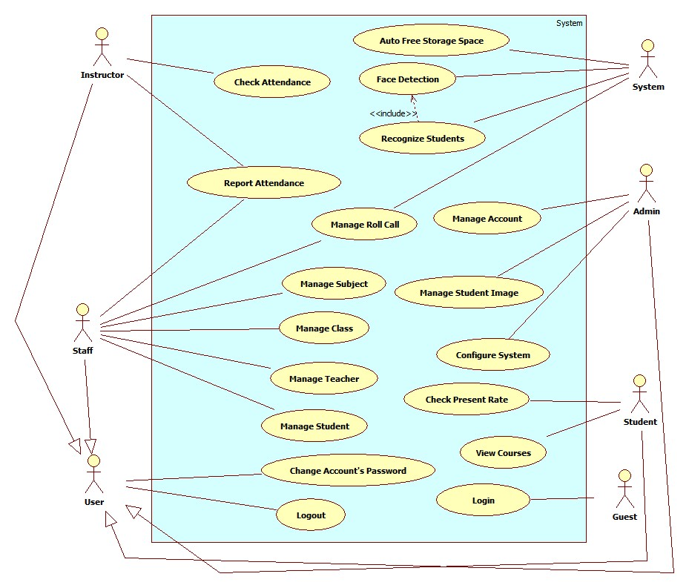

Figure 2 System Overview Use Case

### List of Use Case

#### <Guest>Overview Use Case

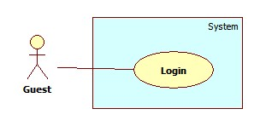

Figure 3: <Guest> Overview Use Case

##### <Guest> Login

Use Case Diagram



Figure 4: <Guest> Login

Use Case Specification

|  |  |  |  |
| --- | --- | --- | --- |
| **USE CASE – GU001** | | | |
| **Use Case No.** | GU001 | **Use Case Version** | 2.0 |
| **Use Case Name** | Login | | |
| **Author** | Pham Huy Hoang | | |
| **Date** | 19/09/2013 | **Priority** | Normal |
| **Actor:** Guest.  **Summary:**  Guest use this case to login into system.  **Goal:**  Allow authentication and authorization of the system.  **Triggers:**   * Guest want to login into system. * To login: Guest go to the login page, guest enter username and password, then click on “Log in” button to login.   **Preconditions:** N/A.  **Post Conditions:**   * **Success:** Guest is authorized, redirect to corresponding page. * **Fail:** System will show error on current page   **Main Success Scenario:**   |  |  |  | | --- | --- | --- | | Step | Actor Action | System Response | | 1 | Guest go to login page | System show a login form, includes:   * Username: textbox (min length: 6, max length: 30, required). * Password: textbox (password box, min length:6, max length: 30, required). * Login: button. | | 1 | Guess enter username and password into textboxs.  Press “Log In” button. | - Guest is logged into system, authorized with corresponding role. Redirect to corresponding page..  [Exception 1,2] |   **Alternative Scenario:** N/A  **Exceptions:**   |  |  |  | | --- | --- | --- | | No | Actor Action | System Response | | 1 | No input in “Username” or “Password” textboxs | Show error message: “Please enter username/password” below Username/Password textbox. | | 2 | Input invalid “Username” and “Password” | Show error message: “Invalid username or password”. |   **Relationships:** N/A  **Business Rules:**   * Each student, instructor, staff, admin has an account. * Only active account can log in. * Only instructor’s account can log in into mobile app. | | | |

Table 13: <Guest> Login

#### < Instructor>Overview Use Case

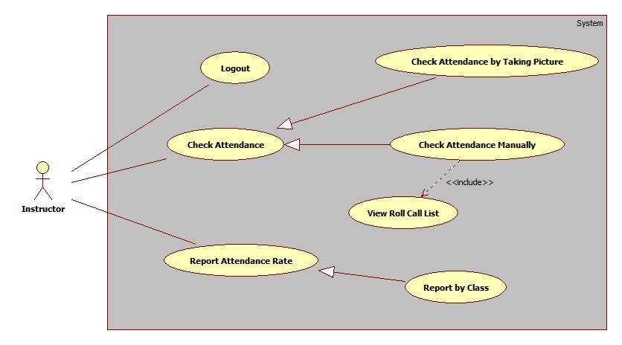

##### <Instructor> Logout

#### < Staff >Overview Use Case

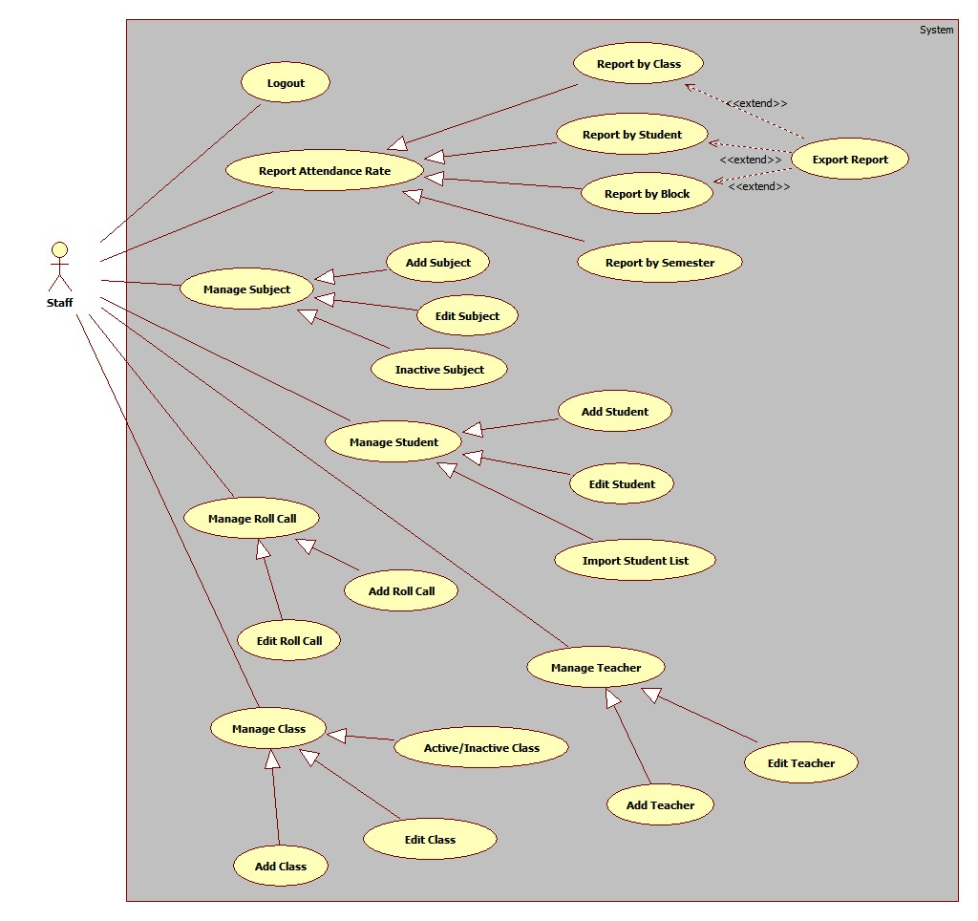

#### <Student> Overview Use Case

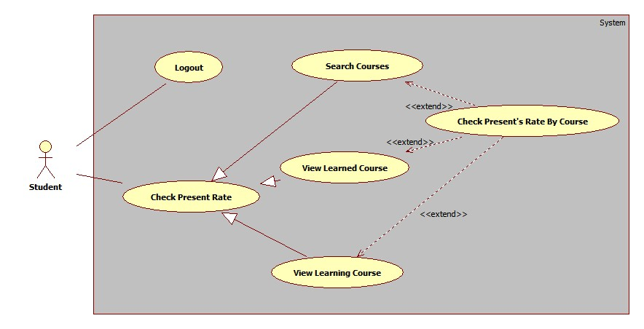

#### <Admin>Overview Use Case

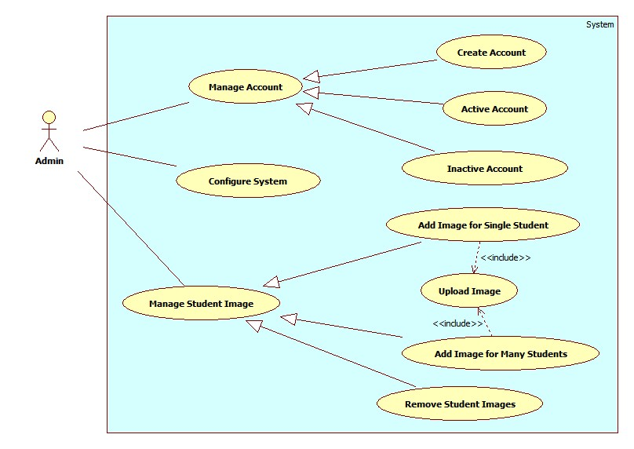

Figure 5: <Admin> Overview Use Case

##### <Admin> Create Account

Use Case Diagram

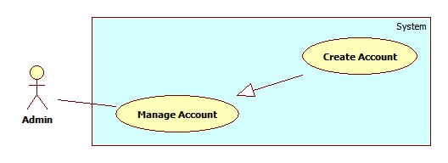

Figure 6: <Admin> Create Account

Use Case Specification

|  |  |  |  |
| --- | --- | --- | --- |
| **USE CASE – AD001** | | | |
| **Use Case No.** | AD001 | **Use Case Version** | 2.0 |
| **Use Case Name** | Create Account | | |
| **Author** | Pham Huy Hoang | | |
| **Date** | 20/09/2013 | **Priority** | Normal |
| **Actor:** Admin  **Summary:**  This user case allow admin to create an account for login the system  **Goal:**  A new account (For student, instructor or staff) will be added to database  **Triggers:**   * In our system, the account of a student or instructor is auto created when staff create new instructor/new student. This function is used to create staff, student or instructor account, in case of backup. * To create a new account, admin must: * From the admin Home Page, click the menu item “Account Manager”. * In the Account Manager Page, click on the Tab “Create Account”. * Input new account information, click “Create” to finish.   **Preconditions:**   * User must logged in the system with the role is admin   **Post Conditions:**   * **Success:** A new account will be created. The acocunt will be displayed on account list. * **Fail:** No acocunt created.Transfer to error page or still in current page.   **Main Success Scenario:**   |  |  |  | | --- | --- | --- | | Step | Actor Action | System Response | | 1 | Click menu item “Account Manager” | Redirect to Account Manager Page, includes a panel with 2 tabs:   * Account List * Create Account   Current tab is Account List. This tab includes:   * Table with 5 column: * Account ID: text * Username: text * Email: text * Role: text * Select: checkbox * Action: dropdownlist, values: Inactive, Active. * Process: button | | 2 | Click Tab “Create Account” | Display a tab panel includes:   * Username: textbox (min length, max length: 30, required). * Password: textbox (password box, min length, max length: 30, required). * Password: textbox (password box, min length, max length: 30, required). * Email: textbox (match regular expression: ^([\w\.])+@([\w])+\.(\w){2,6}(\.([\w]){2,4})*$, min length: 10, max length: 50, required). * Roles : dropdownlist, values: Admin, Staff, Instructor, Student. * Create: button * Reset: button | | 3 | Input new account information. Click “Create” button  [Alternative 1,2] | System will add the account to database.  Show the tab panel “Account List”  [Exception 1,2,3,4,5,6] |   **Alternative Scenario:**   |  |  |  | | --- | --- | --- | | No | Actor Action | System Response | | 1 | Click on “Reset” button | The form is emptied | | 2 | Click on “Account List” tab | Show the content of “Account List” tab |   **Exceptions:**   |  |  |  | | --- | --- | --- | | No | Actor Action | System Response | | 1 | Not enter enough require information. | Display error message: “Please enter all require information.” | | 2 | Username/password is not in range [6,30] | Display error message: “Username/Password must in range [6,30].” | | 3 | Email is not in range [10, 50] | Display error message:  “Username/Password must in range [10,50].” | | 4 | Email not match regular expression | Display error message:  “Invalid email address” | | 4 | Confirm password is not equal password | Display error message:  “Password and confirm not match.” | | 5 | Username or email existed in database | Display error message:  “Username/Email already exist.” |   **Relationships:** Manage Account  **Business Rules:**   * Each account is active when added to database. * The “confirm password” value must match “password” value. | | | |

Table 14: <Admin> Create Account

##### <Admin> Active Account

Use Case Diagram

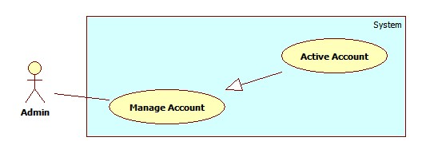

Figure 7: <Admin> Active Account

Use Case Specification

|  |  |  |  |
| --- | --- | --- | --- |
| **USE CASE – AD002** | | | |
| **Use Case No.** | AD002 | **Use Case Version** | 2.0 |
| **Use Case Name** | Active Account | | |
| **Author** | Pham Huy Hoang | | |
| **Date** | 20/09/2013 | **Priority** | Normal |
| **Actor:** Admin  **Summary:**  This user case allow admin to active an accout  **Goal:**  A inactive account will be activated  **Triggers:**   * In our system, when we do not want an user to login, we inactive his/her account (See Use Case – AD003). We can active the inactivated account so they can login again. * To active an account, admin must: * From the admin Home Page, click the menu item “Account Manager”. * Check the Select checkbox of the account record, select “Active” on the drop down list, and press “Process” button.   **Preconditions:**   * User must logged in the system with the role is admin. * There must be at least 1 inactive account in database.   **Post Conditions:**   * **Success:** The selected account(s) will be activated. * **Fail:** No acocunt activated.Transfer to error page.   **Main Success Scenario:**   |  |  |  | | --- | --- | --- | | Step | Actor Action | System Response | | 1 | Click menu item“Account Manager” | Redirect to Account Manager Page, includes a panel with 2 tabs:   * Account List * Create Account   Current tab is Account List. This tab includes:   * Table with 5 column: * Account ID: text * Username: text * Email: text * Role: text * Select: checkbox * Action: dropdownlist, values: Inactive, Active. * Process: button | | 2 | Check the checkboxs of the account(s), select “Active” on the drop down list, and press “Process” button | The selected account(s) will be activated  [Exception 1,2] |   **Alternative Scenario:** N/A  **Exceptions:**   |  |  |  | | --- | --- | --- | | No | Actor Action | System Response | | 1 | The account has already been activated by another admin | Nothing happen, the account(s) status is active | | 2 | Check no checkbox, press “Process” button | Display error message:  “Please select account to activated.” |   **Relationships:** Manage Account  **Business Rules:**   * Admin can’t active/inactive account of themselves or other admin. | | | |

Table 15: <Admin> Active Account

##### <Admin> Inactive Account

Use Case Diagram

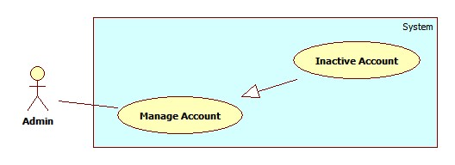

Figure 8: <Admin> Inactive Account

Use Case Specification

|  |  |  |  |
| --- | --- | --- | --- |
| **USE CASE – AD003** | | | |
| **Use Case No.** | AD003 | **Use Case Version** | 2.0 |
| **Use Case Name** | Inactive Account | | |
| **Author** | Pham Huy Hoang | | |
| **Date** | 20/09/2013 | **Priority** | Normal |
| **Actor:** Admin  **Summary:**  This user case allow admin to active an accout  **Goal:**  A active account will be inactivated  **Triggers:**   * In our system, when we do not want an user to login, we inactive his/her account. The account can be activated later. * To active an account, admin must: * From the admin Home Page, click the menu item “Account Manager”. * Check the Select checkbox of the account record, select “Active” on the drop down list, and press “Process” button.   **Preconditions:**   * User must logged in the system with the role is admin * There must be at least 1 active account in database.   **Post Conditions:**   * **Success:** The selected account(s) will be inactivated. * **Fail:** No acocunt inactivated.Transfer to error page.   **Main Success Scenario:**   |  |  |  | | --- | --- | --- | | Step | Actor Action | System Response | | 1 | Click menu item“Account Manager”. | Redirect to Account Manager Page, includes a panel with 2 tabs:   * Account List * Create Account   Current tab is Account List. This tab includes:   * Table with 5 column: * Account ID: text * Username: text * Email: text * Role: text * Select: checkbox * Action: dropdownlist, values: Inactive, Active. * Process: button | | 2 | Check the checkboxs of the account, select “Inactive” on the drop down list, and press “Process” button. | The selected account(s) will be inactivated.  [Exception 1,2] |   **Alternative Scenario:** N/A  **Exceptions:**   |  |  |  | | --- | --- | --- | | No | Actor Action | System Response | | 1 | The account has already been inactivated by another admin. | Nothing happen, the account(s) status is inactive | | 2 | Check no checkbox, press “Process” button. | Display error message:  “Please select account to inactivated.” |   **Relationships:** Manage Account  **Business Rules:**   * Admin can’t active/inactive account of themselves or other admin. | | | |

Table 16: <Admin> Inactive Account

##### <Admin> Config System

Use Case Diagram

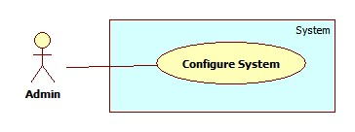

Figure 9: <Admin> Config System

Use Case Specification

|  |  |  |  |
| --- | --- | --- | --- |
| **USE CASE – AD004** | | | |
| **Use Case No.** | AD004 | **Use Case Version** | 2.0 |
| **Use Case Name** | Configure System | | |
| **Author** | Pham Huy Hoang | | |
| **Date** | 20/09/2013 | **Priority** | Normal |
| **Actor:** Admin  **Summary:**  This user case allow admin to configure system’s properties.  **Goal:**  Change current properties of the system  **Triggers:**   * For some reason, administrator needs to re-configure system’s properties. * To config the system, admin must: * Click menu item“Configuration”. * On the configuration page, edit properties and click on “Update” button corresponding with each properties in list.   **Preconditions:**   * User must logged in the system with the role is admin.   **Post Conditions:**   * **Success:** System’s properties is updated to new value. * **Fail:** Nothing changed.   **Main Success Scenario:**   |  |  |  | | --- | --- | --- | | Step | Actor Action | System Response | | 1 | Click menu item “Configuration”. | Redirect to System Configuration Page, with list of system’s properties include:   * Name: text * Value: textbox * Update: button | | 2 | Edit property value and click “Update” button. | Show confirms windows with message:  “Are you sure to change this property?” | | 3 | Click “Ok” to confirm.  [Alternative 1] | Update property value to new value. |   **Alternative Scenario:**   |  |  |  | | --- | --- | --- | | No | Actor Action | System Response | | 1 | Click “Cancel”. | Nothing happen, the value is unchanged. |   **Exceptions:** N/A  **Relationships:** N/A  **Business Rules:**   * Configure system’s properties will affect to all function using these properties.. | | | |

Table 17: <Admin> Config System

##### <Admin> Add Image for Single Student

Use Case Diagram

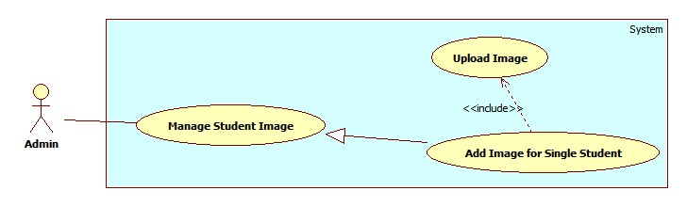

Figure 10: <Admin> Add Image for Single Student

Use Case Specification

|  |  |  |  |
| --- | --- | --- | --- |
| **USE CASE – AD005** | | | |
| **Use Case No.** | AD005 | **Use Case Version** | 2.0 |
| **Use Case Name** | Add Image for Single Student | | |
| **Author** | Pham Huy Hoang | | |
| **Date** | 20/09/2013 | **Priority** | Normal |
| **Actor:** Admin  **Summary:**  This user case allow admin add image data for a student.  **Goal:**  Image of a students will be stored on server, the links to images is stored in database  **Triggers:**   * For face recognition, our system must store images of students face. With more images, we can have better recognition accuracy. * To add new image for a single student, admin must: * Click menu item“Manage Student Image” -> “Student List”. * On the Student List Page, click Detail to view image data of a student. * Upload images. System will detect human faces from uploaded images. * Select the student faces from images. * Press “Save” to save the images.   **Preconditions:**   * User must logged in the system with the role is admin. * There must be at lease one student in the student list. * The admin has images contain the student’s face.   **Post Conditions:**   * **Success:** The images of a student will be stored on server and database * **Fail:** No image added   **Main Success Scenario:**   |  |  |  | | --- | --- | --- | | Step | Actor Action | System Response | | 1 | Click menu item “Manage Student Image” -> “Student List”.  [Alternative 1] | Redirect to Student List Page, contains :   * Table with 4 columns, record of 30 lastest students: * Student Code: text * Name: text * Email: text * Image Data: “Detail” button * Class: Dropdownlist, value: All active class in database. | | 2 | Click on “Detail” button  [Alternative 2] | A pop-up is displayed. The pop-up show the detail of Student Image Data, include:   * Student Current Image: A list of images * File Upload Control * Upload: button | | 2 | Select the student’s images from computer | The selected images will be displayed as thumbnails.  [Exception 1] | | 3 | Click “Upload” button | System will detect student faces from uploaded images, then display image full size with white **face regions** (See Use Case SY002)  [Exception 2, 3] | | 4 | Select student’s face from face region.  Click “Save” button. | The selected face region will be cropped from original picture, stored into server. Face’s owner and link will be stored in database. [Exception 4]  The pop-up is closed. The Student List Page is auto refresh. |   **Alternative Scenario:**   |  |  |  | | --- | --- | --- | | No | Actor Action | System Response | | 1 | Select a class from Class drop down list | A table show the records of all students in selected class.  Table with 4 columns:   * Student Code: text * Name: text * Email: text * Image Data: “Detail” button | | 2 | Close pop-up | The pop-up is closed. |   **Exceptions:**   |  |  |  | | --- | --- | --- | | No | Actor Action | System Response | | 1 | Select more than 20 images | Display error message: “ Too much images. Only process first 20 images” | | 2 | Not select image, click “Upload” button | Display error message: “Please choose images for uploading” | | 3 | Upload images don’t contain human faces.  No faces detected from uploaded images | Display error message: “ No face found. Select another images” | | 4 | The selected face already in the database | Display message: “Face XXX existed in database” |   **Relationships:** Manage Student Image  **Business Rules:**   * For saving storage space, only student’s face is stored. The face is saved as jpeg, resolution 100 x 100. * The recommend number of image for a student is >10 for acceptable accuracy. * The original uploaded images wil lbe stored on Temp folder on server. This Temp folder will be emptied at time interval (See Use Case SY001). | | | |

Table 18: <Admin> Add Image for Single Student

##### <Admin> Add Image for Multi Student

Use Case Diagram

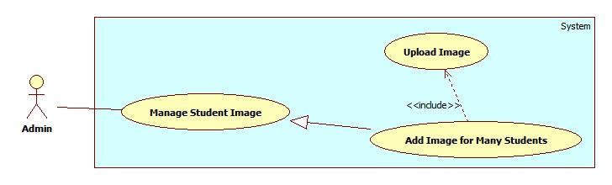

Figure 11: <Admin> Add Image for Multi Student

Use Case Specification

|  |  |  |  |
| --- | --- | --- | --- |
| **USE CASE – AD006** | | | |
| **Use Case No.** | AD006 | **Use Case Version** | 2.0 |
| **Use Case Name** | Add Image for Multi Student | | |
| **Author** | Pham Huy Hoang | | |
| **Date** | 20/09/2013 | **Priority** | Normal |
| **Actor:** Admin  **Summary:**  This user case allow admin to add image data for many students.  **Goal:**  Image of students will be stored on server, the links to images is stored in database  **Triggers:**   * For face recognition, our system must store images of students face. With more images, we can have better recognition accuracy. * To add new image for a single student, admin must: * Click menu item“Manage Student Image” -> “Add Image for Students”. * Upload images. System will detect student faces from uploaded images. * Select the student faces from images. * Select the each face’s owner. * Press “Save” to save the images and students.   **Preconditions:**   * User must logged in the system with the role is admin. * There must be at lease one student in the student list. * The admin has images contain the student’s face.   **Post Conditions:**   * **Success:** The images of students will be stored on server and database * **Fail:** No image added   **Main Success Scenario:**   |  |  |  | | --- | --- | --- | | Step | Actor Action | System Response | | 1 | Click menu item “Manage Student Image” -> “Add Image for Students”. | Redirect to Add Image for Students Page, contains:   * Upload Students Images: text label * File Upload Control * Upload: button | | 2 | Select the student’s images from computer | The selected images will be displayed as thumbnails.  [Exception 1] | | 3 | Click “Upload” button | System will detect student faces from uploaded images, then display image full size with white **face regions** (See Use Case SY002)  [Exception 2, 3] | | 4 | Select student’s face from face region, select the face owner | When user hover into a face region, a suggestion textbox is displayed.  The auto-complete textbox’s source is all students in database. A suggestion record includes:   * Student Face: image * Student ID: text * Full name: text * Class: text   Admin can select the face’s owner. | | 5 | Click “Save” button | The selected face region will be cropped from original picture, stored into server. Face’s owner and link will be stored in database. [Exception 4] |   **Alternative Scenario:** N/A  **Exceptions:**   |  |  |  | | --- | --- | --- | | No | Actor Action | System Response | | 1 | Select more than 20 images | Display error message: “ Too much images. Only process first 20 images” | | 2 | Not select image, click “Upload” button | Display error message: “Please choose images for uploading” | | 3 | Upload images don’t contain human faces.  No faces detected from uploaded images | Display error message: “ No face found. Select another images” | | 4 | The select face already in the database | Display message: “Face XXX existed in database” |   **Relationships:** Manage Student Image  **Business Rules:**   * The same as Use Case AD005. * The auto-complete textbox must show the student’s face, name, ID and class, as the same as facebook. | | | |

Table 19: <Admin> Add Image for Multi Students

##### <Admin> Remove Student Image

Use Case Diagram

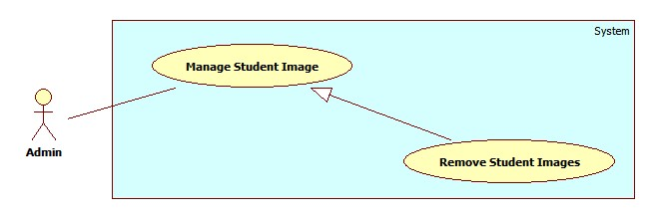

Figure 12: <Admin> Remove Student Image

Use Case Specification

|  |  |  |  |
| --- | --- | --- | --- |
| **USE CASE – AD007** | | | |
| **Use Case No.** | AD007 | **Use Case Version** | 2.0 |
| **Use Case Name** | Remove Student Image | | |
| **Author** | Pham Huy Hoang | | |
| **Date** | 20/09/2013 | **Priority** | Normal |
| **Actor:** Admin  **Summary:**  This user case allow admin to remove image of a student.  **Goal:**  Remove an/many images from a student Image Data  **Triggers:**   * For face recognition, our system must store images of students face. Sometimes, the admin can add the wrong face of students, which lower the accuracy. So the admin must be able to remove image of a student. * To remove image of a single student, admin must: * Click menu item“Manage Student Image” -> “Student List”. * On the Student List Page, click Detail to view image data of a student. * Click on the “X” button at the top-right corner of the image. * Click “Ok”   **Preconditions:**   * User must logged in the system with the role is admin. * There must be at lease one student in the student list. This student must has at least 1 face image.   **Post Conditions:**   * **Success:** The image of a student will be removed from server and database * **Fail:** No image removed   **Main Success Scenario:**   |  |  |  | | --- | --- | --- | | Step | Actor Action | System Response | | 1 | Click menu item“Manage Student Image” -> “Student List”.  [Alternative 1] | Redirect to Student List Page, with list student with columns:   * Student Code: text * Name: text * Email: text * Image Data: “Detail” button   Class: Dropdownlist, value: All active class in database. | | 2 | Click on “Detail” button  [Alternative 2] | A pop-up is displayed. The pop-up show the detail of Student Image Data, include:   * Student Current Image: A list of images * File Upload Control * Upload: button | | 3 | Click on the “X” button at the top-right corner of the image | Show confirms windows with message:  “Are you sure to delete this image?” | | 4 | Click “Ok”  [Alternative 3] | The selected image will be removed from server and database.  An message is display: “Image XXX removed”. |   **Alternative Scenario:**   |  |  |  | | --- | --- | --- | | No | Actor Action | System Response | | 1 | Select a class from Class drop down list | A table show the records of all students in selected class.  Table with 4 columns:   * Student Code: text * Name: text * Email: text * Image Data: “Detail” button | | 2 | Close pop-up | The pop-up is closed. | | 3 | Click “Cancel” | The image is not removed. |   **Exceptions:** N/A  **Relationships:** Manage Student Image  **Business Rules:** N/A | | | |

Table 20: <Admin> Remove Student Images

#### <System> Overview Use Case

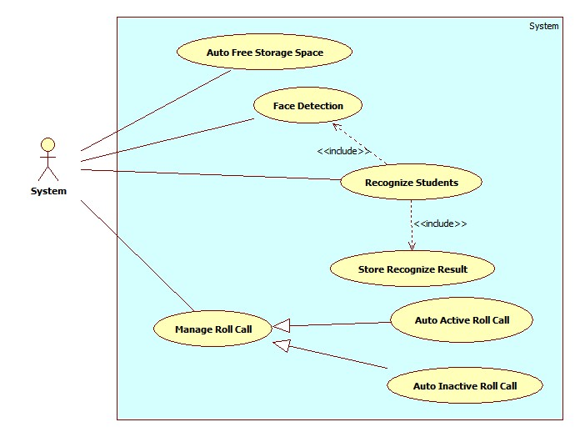

Figure 13: <System> Overview Use Case

##### <System> Auto Free Storage Space

Use Case Diagram

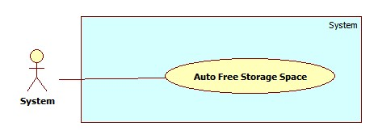

Figure 14: <System> Auto Free Storage Space

Use Case Specification

|  |  |  |  |
| --- | --- | --- | --- |
| **USE CASE – SY001** | | | |
| **Use Case No.** | SY001 | **Use Case Version** | 2.0 |
| **Use Case Name** | Auto Free Storage Space | | |
| **Author** | Pham Huy Hoang | | |
| **Date** | 21/09/2013 | **Priority** | Normal |
| **Actor:** System.  **Summary:**  This use case is used to auto free space on server  **Goal:**  Delete the image in the Temp folder to free space on server.  **Triggers:**   * When admin upload images for Managed Student Images (See Use Case AD005), those images will be stored in Temp folder. * At 0.00am, or when the size of Temp folder is bigger than 500MB, the Temp folder will be emptied for free space.   **Preconditions:** N/A.  **Post Conditions:**   * **Success:** The Temp folder is emptied. * **Fail:** No images deleted from temp folder   **Main Success Scenario:**   |  |  |  | | --- | --- | --- | | Step | Actor Action | System Response | | 1 | - Time hit 0.00am  - Size of Temp folder is bigger than 500MB | Delete all the images in Temp Folder |   **Alternative Scenario:** N/A  **Exceptions:** N/A  **Relationships:** N/A  **Business Rules:** N/A | | | |

Table 21: <System> Auto Free Storage Space

##### <System> Face Detection

Use Case Diagram

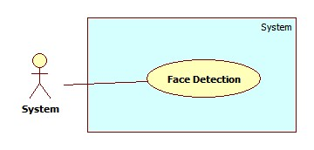

Figure 15: <System> Face Detection

Use Case Specification

|  |  |  |  |
| --- | --- | --- | --- |
| **USE CASE – SY002** | | | |
| **Use Case No.** | SY002 | **Use Case Version** | 2.0 |
| **Use Case Name** | Face Detection | | |
| **Author** | Pham Huy Hoang | | |
| **Date** | 21/09/2013 | **Priority** | Normal |
| **Actor:** System.  **Summary:**  This use case is used to detect the face regions in an image  **Goal:**  Detect the face regions in an image  **Triggers:**   * When admin upload images for Manage Student Image (See Use Case AD005), or instructor send images for Checking Attendance (See Use Case IN00X), system will detect the face regions in the upload images. * The detected region will be displayed at client, or used to recognize the students in the images.   **Preconditions:**   * The images are uploaded to server successful.   **Post Conditions:**   * **Success:** The face regions is detected. * **Fail:** No face detected   **Main Success Scenario:**   |  |  |  | | --- | --- | --- | | Step | Actor Action | System Response | | 1 | - Admin upload image for Manage Student Image  - Instructor send image for Checking Attendance | Detect the face in the images, create a list of face regions. A face region’s properties:   * Top position * Left position * Height * Width   The face region can be stored as Image Data for Students, or for Student Recognition (See Use Case SY003)  [Exception 1,2] |   **Alternative Scenario:** N/A  **Exceptions:**   |  |  |  | | --- | --- | --- | | No | Actor Action | System Response | | 1 | The upload image is corrupt | Show error message: “The image XXX is corupted”. | | 2 | Upload images don’t contain human faces.  No faces detected from uploaded images. | Display error message: “ No face found. Select another images” |   **Relationships:** N/A  **Business Rules:**   * The accuracy of face detection is >80%. Picture with higher brightness and resolution will has higher accuracy. * If the uploaded images are too big, the image will be resized for faster processing. | | | |

Table 22: <System> Face Detection

##### <System> Recognize Student

Use Case Diagram

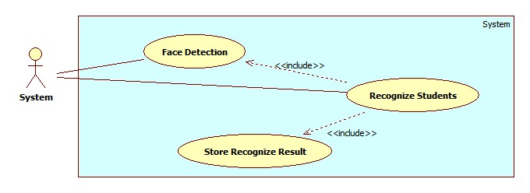

Figure 16: <System> Recognize Student

Use Case Specification

|  |  |  |  |
| --- | --- | --- | --- |
| **USE CASE – SY003** | | | |
| **Use Case No.** | SY002 | **Use Case Version** | 2.0 |
| **Use Case Name** | Recognize Student | | |
| **Author** | Pham Huy Hoang | | |
| **Date** | 21/09/2013 | **Priority** | Normal |
| **Actor:** System.  **Summary:**  This use case is used to detect the face regions in an image  **Goal:**  Detect the face regions in an image  **Triggers:**   * When instructor send images for Checking Attendance (See Use Case IN00X), system will detect the face regions in the upload images. After that, the system will recognize the student present in the images. * The recognized student list will be stored as attendance log in database.   **Preconditions:**   * The images are uploaded to server successful. * The Image Data of the students must existed in database (At least 10 images). If a student doesn’t have image in database, that student will be recognized as “Unknow”   **Post Conditions:**   * **Success:** The students are recognized from images. Recognize result will be stored. * **Fail:** No student recognized. No log stored.   **Main Success Scenario:**   |  |  |  | | --- | --- | --- | | Step | Actor Action | System Response | | 1 | Instructor send image for Checking Attendance | The same as step 1 , Use Case SY002.   * Detect face regions in the picture. * Create a face matching list. * Each face will be matched to find the face’s owner. * After recognizing, show the result and store the result to database.   [Exception 1,2,3] |   **Alternative Scenario:** N/A  **Exceptions:**   |  |  |  | | --- | --- | --- | | No | Actor Action | System Response | | 1 | A student is recognized more than one time in an image | Show error message: “Student XXX detect more than one time. Please check”. | | 2 | The number of student detected is too small (<5) | Show error message: “Only some students detected. Please check”. | | 2 | Find unknow people in the image | Alert: “Stranger Detected. Please check”. |   **Relationships:** Face Detection, Face Recogntion, Store Recognize Result  **Business Rules:**   * The accuracy of face recognition is 60~80%, depend on the number of image in training data. * The recommend number of image for a student is >10 for acceptable accuracy. * When stranger is detected, a log will be stored for later checking. | | | |

Table 23: <System> Recognize Student

##### <System> Auto Active Roll Call

Use Case Diagram

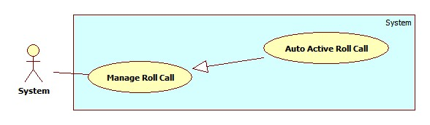

Figure 17: <System> Auto Active Roll Call

Use Case Specification

|  |  |  |  |
| --- | --- | --- | --- |
| **USE CASE – SY004** | | | |
| **Use Case No.** | SY004 | **Use Case Version** | 2.0 |
| **Use Case Name** | Auto Active Roll Call | | |
| **Author** | Pham Huy Hoang | | |
| **Date** | 21/09/2013 | **Priority** | Normal |
| **Actor:** System.  **Summary:**  This use case is used to auto active a roll call  **Goal:**  The roll call on roll call list will be activated when begin date is current date  **Triggers:**   * System will auto active a roll call when begin date is current date. * When a roll call is activated, its status in Roll Call List will be “Active”. * The instructor can only take attendance of an active roll call list.   **Preconditions:** N/A.  **Post Conditions:**   * **Success:** System will auto active a roll call. * **Fail:** No roll call activated   **Main Success Scenario:**   |  |  |  | | --- | --- | --- | | Step | Actor Action | System Response | | 1 | Roll call begin date is current date. The system auto activate a roll call. | The roll call status become “Active”.  The roll call is show on instructor’s phone. The instructor can take attendance of the roll call. |   **Alternative Scenario:** N/A  **Exceptions:** N/A  **Relationships:** Manage Roll Call  **Business Rules:**   * A roll call has 3 status: Created, Active, Inactive. * Staff manage the info of a roll call, but staff can’t active/inactive rollcall manually. * When a roll call is Active, the staff can only Change the Instructor, or Add/Remove Student. | | | |

Table 24: <System> Auto Active Roll Call

##### <System> Auto Inactive Roll Call

Use Case Diagram

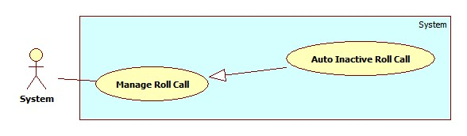

Figure 18: <System> Auto Inactive Roll Call

Use Case Specification

|  |  |  |  |
| --- | --- | --- | --- |
| **USE CASE – SY005** | | | |
| **Use Case No.** | SY005 | **Use Case Version** | 2.0 |
| **Use Case Name** | Auto Active Roll Call | | |
| **Author** | Pham Huy Hoang | | |
| **Date** | 21/09/2013 | **Priority** | Normal |
| **Actor:** System.  **Summary:**  This use case is used to auto inactive a roll call  **Goal:**  The roll call on roll call list will be inactivated when end date expired.  **Triggers:**   * System will auto inactive a roll call when end date expired. * When a roll call is inactivated, its status in Roll Call List will be “Inactive”. * The instructor can’t take attendance of an active roll call list. The staff can’t edit info of an inactive roll call.   **Preconditions:** N/A.  **Post Conditions:**   * **Success:** System will auto inactive a roll call. * **Fail:** No roll call activated   **Main Success Scenario:**   |  |  |  | | --- | --- | --- | | Step | Actor Action | System Response | | 1 | Roll call end date expired. The system auto inactivate a roll call. | The roll call status become “Inactive”.  The roll call not show instructor’s phone. |   **Alternative Scenario:** N/A  **Exceptions:** N/A  **Relationships:** Manage Roll Call  **Business Rules:**   * A roll call has 3 status: Created, Active, Inactive. * Staff manage the info of a roll call, but staff can’t active/inactive rollcall manually. * When a roll call is Inactive, the staff can’t edit the roll call info. The instructor can’t take attendance of an inactive roll call. | | | |

Table 25: <System> Auto Inactive Roll Call

## Software System Attribute

### Usability

#### Graphic User Interface

* All the text, label and image in staff, instructor, student page should be English.
* All the text, label and image in admin page should be English.

#### Usability

* Website admin, staff and instructor should need more than one week of training to be productive with the system.
* The student can use the system easyly without training.

#### Installation

* The system must be easy to deploy. Customer can deploy successfully and learn to configure, maintain the system within one day of training.
* The mobile app must be easy to install. Compatible with almost Android Phone.
* The attached manual guide must be clear. User can read and do themselves without developer’s help.

### Reliability

* N/A

### Availability

* N/A

### Security

* Privacy: Each role of user has a specific permission to interact with system.
* System always checks authorization and authenticated before doing anything.
* Only admin can grant permission to staff.

### Maintainability

* N/A

### Portability

* N/A

### Performance

* Detect Faces From an Image: 3~4 seconds/image.
* Recognize Faces : 20~30 seconds/100 faces. With training set of 30 students, 600 images.
* The image upload speed depend on the speed of the network.

## ERD

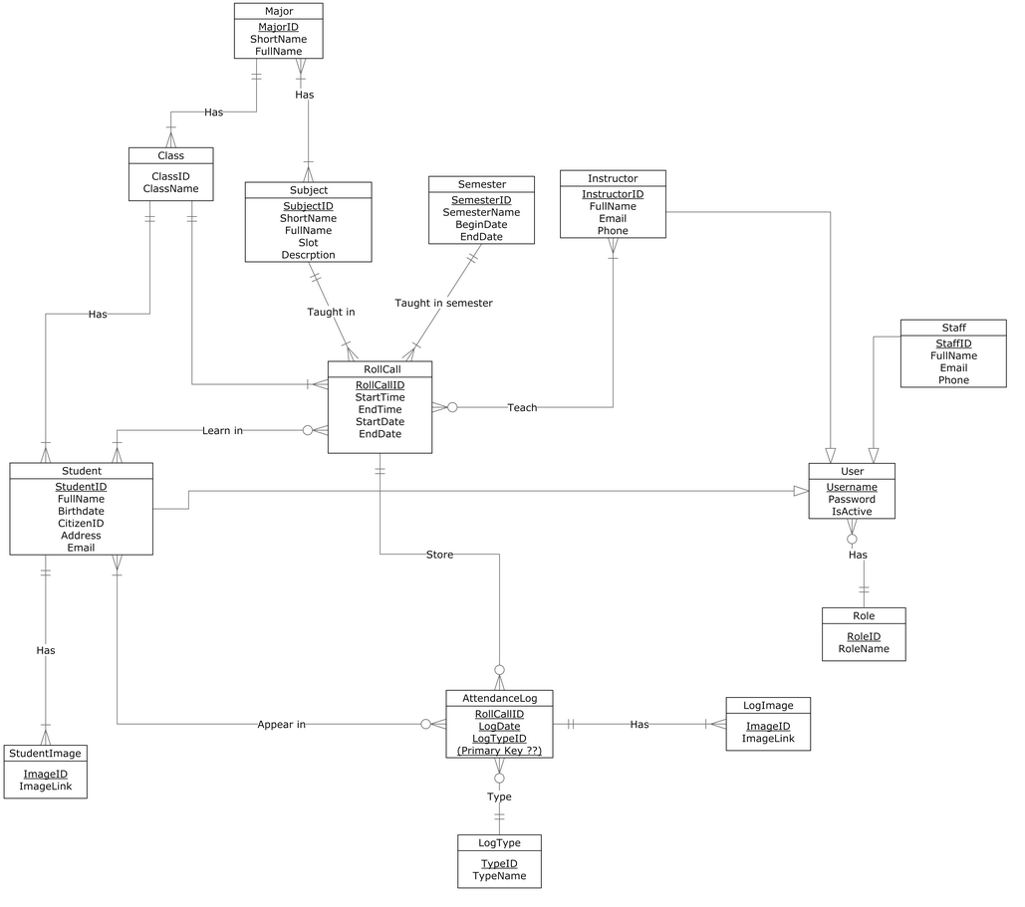

Figure 19: ERD - Conceptual Diagram